
6 Poles Hill
Chesham, Bucks HP5 2QP
Tel: +44 (0) 777 55 20 459

www.qualtrak.com
Registration No. 4478853

Reference for Garrard Kitchen, CTO for Qualtrak Solutions

To whom it may concern

My first involvement with Garrard (2007) was as a contractor responsible for developing an API. The solution he worked on was a client-based application using an Access Database. During this project I quickly realized that Garrard had the potential to grow significantly and decided to take him on as an employee.
As a result of his work we were able to break into the US market with an innovative and unique solution which to this day no other vendor has been able to match (i.e. being able to integrate our call centre agent training solution with any call recorder.) This enabled us to gain an important strategic advantage which then led us to being invited by a major UK call recording vendor to convert our client-based agent training solution to a web-based version (to be funded by the vendor).
At this time there were no call centre ‘cloud based’ agent development products anywhere in the world. With Garrard’s enthusiasm and confidence, we decided that rather than delivering an on-premise solution as requested, we would take a leap and be the first in the world (competing against large international market leaders) to bring out a cloud-based/multi-tenant based version. If it wasn’t for Garrard’s confidence and vision a small company such as Qualtrak will have never taken this step and achieved such an important prize.
Garrard went on to demonstrate similar characteristics and vision with a number of similar circumstances enabling us to be highly innovative and pioneering. An example is with AWS (Amazon Web Services). About 3 years ago AWS launched a unique cloud-based contact center platform and Qualtrak was invited to consider being one of the first agent performance improvement vendors to integrate and supply its solution on the AWS Marketplace. Again, Garrard grasped the challenge and today we carry the honour of being the first to bring to market a solution for AWS carrying the premium integration standard (called AWS QuickStart). Previously Garrard had no experience working with AWS technologies but characteristically he grasped the change and became self-taught by spending many 100s of hours studying in his own time.
I can list many more examples of Garrard’s approach to performing his role as a Chief Technology Officer. Garrard is much more than that. He is extremely bright and dedicated to working to the highest technical standards. The most recent achievement is our latest solution called Omnichannel CXcoach. The call centre market is undergoing an enormous transformation from legacy call centre technologies to meeting the needs of the modern customer i.e. demanding to engage with a brand not exclusively via a voice channel but through any channel of their choice i.e. social, chat, SMS, email etc. We recognized that the training needs of the ‘new’ agents i.e. working in an omnichannel environment requires a different method of training. Characteristic of Garrard’s way of approaching challenges once again with Garrard’s central contribution we have recently launched the world’s first specially developed and unique agent training solution for ‘omnichannel’ contact centers.
Garrard is a very talented computer software leader. He is very hardworking, honest and loyal person. The above insights demonstrate his strengths and personal loyalty he has shown towards me, his team, colleagues and the company. He loves working to the highest standards. This applies not only to technical standards but also by the way he loves developing and inspiring developers that work for him. They respect him totally for who he is and also for the care he shows as a ‘teacher/mentor’ to his team. Garrard also has the respect of other colleagues in the company. He is incredibly patient and willing to help his colleagues no matter what the issue is. He shows exactly the same patter of behaviours towards our customers by being responsive and committed to meeting their needs to their full satisfaction.

I believe that Garrard has much more to contribute and a willingness to wanting to grow continuously as a professional leader and technical master. I shall personally miss having the satisfaction of working with Garrard. However, I consider myself highly fortunate to have had the pleasure in working with him for the past 12 years and I have absolutely no hesitation in recommending Garrard to his new employer. I will be delighted to enlarge on the above verbally during the recruitment phase.

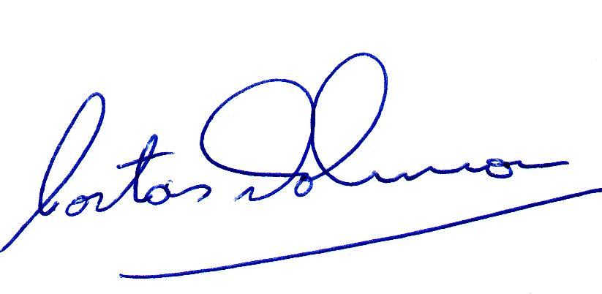

Costas Johnson
CEO, Qualtrak Solutions Ltd
May 3rd, 2019

